TRUCK TURMOIL FOR OUR STREETS
WHAT IS HAPPENING?
Woolworths is proposing to reroute truck traffic through our neighbourhood streets to accommodate its planned shopping complex. The development aims to utilise Culloden Road as the main entry point for deliveries. As a result, approximately 60 delivery/service vehicles (conservative estimate) will be shifted from the Arnisdale Rd entrance to our residential streets. This change will have a significant effect on the safety and well-being of our community, both now and for future generations.
WHERE WILL BE IMPACTED?
The submitted plans have not specified truck routes for Woolworths’ trucks and other trucks servicing the centre. Due to the location of the site and access point, these huge trucks (up to 19 metres) must use Duncraig residential streets to gain access to Culloden Road. Traffic assessments of these local streets have been excluded from the provided planning documents. These roads are considered ‘local access’ or ‘local distributor roads’ by Main Roads and are not to be used as a truck route under the road classification definitions. These trucks are a threat to our safety and peaceful suburb.
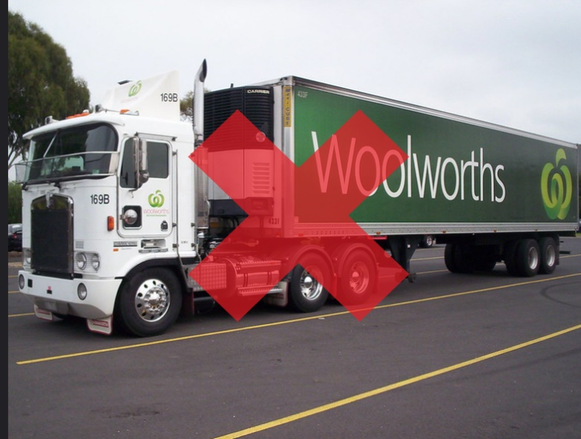
Impacted streets:
- Carlyle Cresent
- Kinloch Place
- Glengarry Drive
- Culloden Road
- Timor Street
- Cimbrook Way
- Alder Way
- Dinroy Street
- Arnisdale Way (residential end)
- Merrick Way

For further information please see plans and other supporting documents:
59 Arnisdale Road, Duncraig – Redevelopment Of Glengarry Shopping Centre | City of Joondalup
Please sign the petition and submit your objections using the link above.

